1. Bushing Pulley/Spindle/Drum/Capstan:
2. With the Bushing Pulley files printed, make sure the Bushing/Bearing Shell fits on top of the drum. Shouldn't be too loose or too tight. Top Part needs to fit on top as well with a somewhat secure fit. Also assure the pulley fits onto the motor shaft. Shouldn’t be too tight or loose. If things don't fit, adjust with the included .f3d file or pm me.
3. Spread some epoxy 2 part glue on the printed file.
4. Slide the Bushing/Bearing Shell on top. Put on the top part as well.
5. Put some weight on the Pulley and let it dry for 24h under pressure
6. Make sure the bushing holds well. It should be very rigid.
7. Wrap some grippy tape around the pulley. I used kinesio tape, which works quite well

Ein Bild, das Zylinder, Hartwaren, Metall, Silber enthält.
Ein Bild, das Kreis, Zylinder, Hartwaren, Metall enthält.
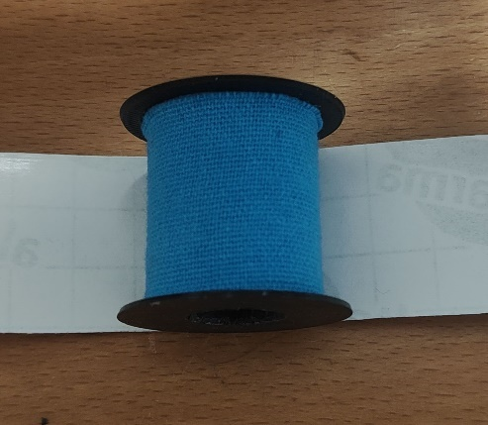

1. Clean the MGN12H Rail and Wagon (e.g. soaking in 99% isopropyl alcohol)
2. Screw the MGN12H Rail wagon to the Motor Head Back with 4 Hex Cap M3x12 screws
3. Mount the Motor Head Back to the Motor with Armpit’s 60AIM40F Ring behind (optional, if you want PitClamp Mounting) with 2 Hex Cap M5x45, 2 Countersunk M5x45 Screws and 4 M5 Nuts on the back. Make sure the Motor Terminal and the Notch in the Motor Ring are aligned to each other and the cable hole in the Motor Head Back right below the motor shaft.

Ein Bild, das Autoteile, Kreis, Gelände, Teil enthält.
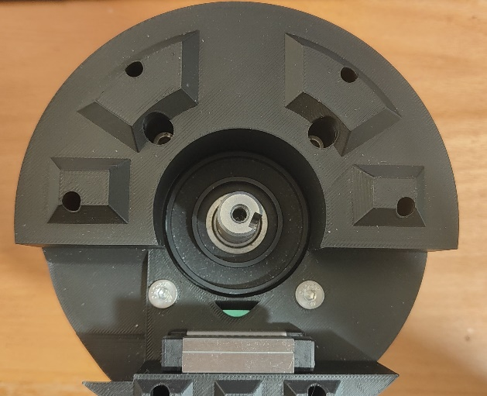 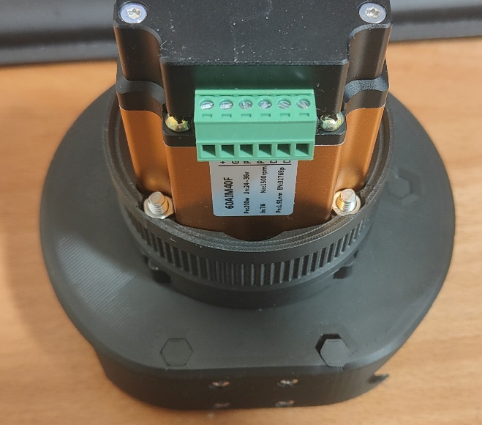

1. Insert 2 MR115 bearings into the 8mm end pulley, 3 MR115 bearings into the 12mm end pulley.
2. Secure the 8mm Pulley to the end effector and the 12mm end pulley to the rail end with a ISO 7380 M5x20 screw each.
3. Slide End Effector and Rail End onto the rail as pictured below. Secure the End Effector with 2x M3x16 Hex Cap Screws and the Rail End with 1x M3x12 Hex Cap Screw

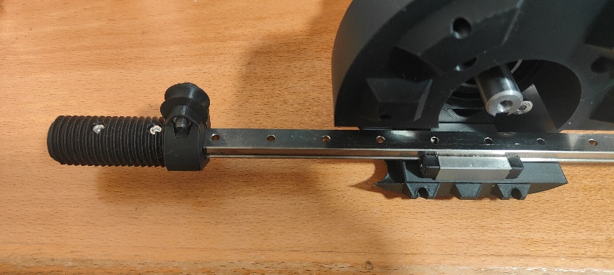 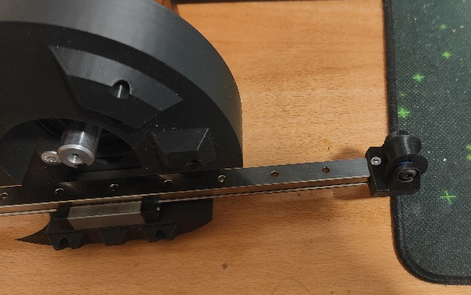

1. Channel the jst and 2 pin cable through the central hole below the motor shaft on the Motor Head Back
2. Slide the Pulley onto the motor head. Do not slide it on completely, just push it on enough for it to have a somewhat stable fit. This will make the wrapping of the rope easier.
3. Slide the motor head on the rail so it is roughly centered to the usable rail.
4. Take the rope and tie one end to a hole on the rail of your choosing. This makes the wrapping of the rope easier. Leave a generous length of rope on this end. Do not cut the rope.
5. Guide the rope around the end pulleys and the capstan like pictured below.

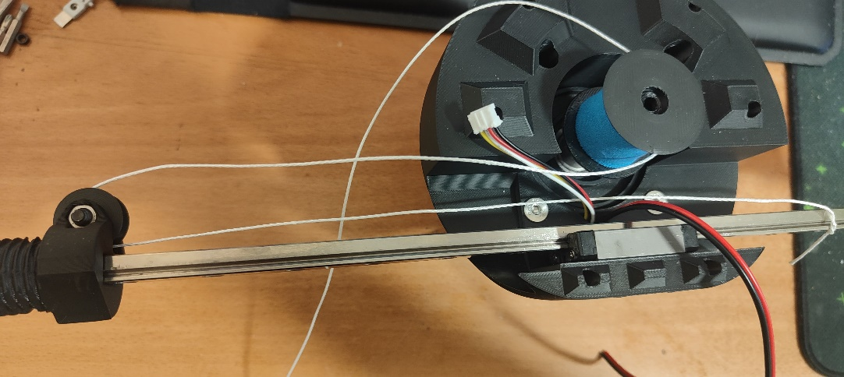

1. Ein Bild, das Elektrische Leitungen, Kabel, Elektronik, Im Haus enthält.

   KI-generierte Inhalte können fehlerhaft sein.Wrap the rope rather tightly around the capstan pulley. Try to keep the wraps on the drum roughly centered. The amount of wraps I used was 8, which works well with the Kinesio tape I used. Your mileage may vary depending on which tape you used. This is something you may need to play around with. More wraps have only the disadvantage of taking up more space, which makes it not possible to accommodate higher rail lengths. 8 wraps works well with 450mm rail length. Not enough wraps will result in slipping of the rope. The more wraps, the harder it is for the rope to slip.
2. If you use the 3d printed Pulley with the integrated grooves (not the bushing pulley), same applies here, though you will need less wraps. 5 was enough if I remember correctly.
3. Guide the rope as pictured below

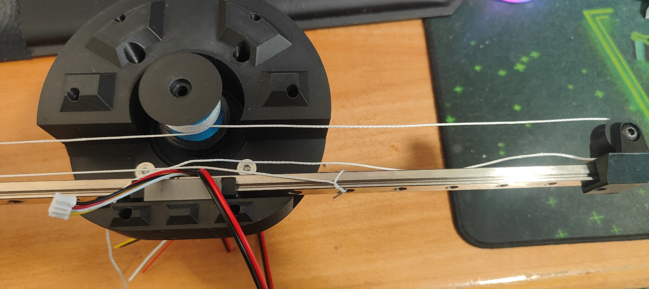

1. You can let go of the rope. This will relieve some tension from the wraps, but that is no problem, we can tension it as much as we like later.
2. Push the pulley onto the motor shaft completely. Screw it onto the shaft using a ISO 7380 M5x12 screw. You don’t need to screw it very tight.
3. Take the Motor Head Front part. Push in the standoffs in the fitting slots. Use violence if needed.
4. Push 4 M4 and 1 M5 Nuts into the lower part of the tensioner.
5. Insert the lower part of the tensioner into the Motor Head front part as pictured below. Insert the M5x80 screw from the appropriate hole on top and screw it into the lower tensioner part.

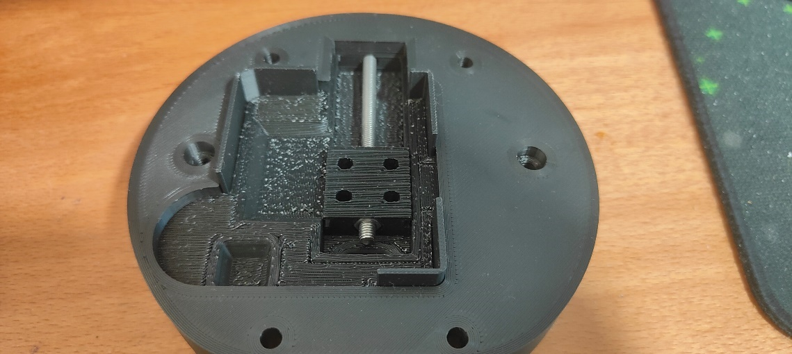

1. Push the Tensioner around a bit to make sure it moves around.
2. Put the Motor Head Front onto the Motor Head Back. For this, first guide the jst and 2 pin cables through the hole just below the tensioner. Then untie the rope end and guide both rope ends through the same hole.

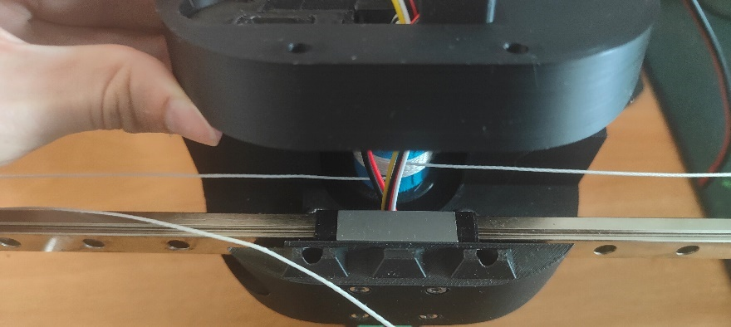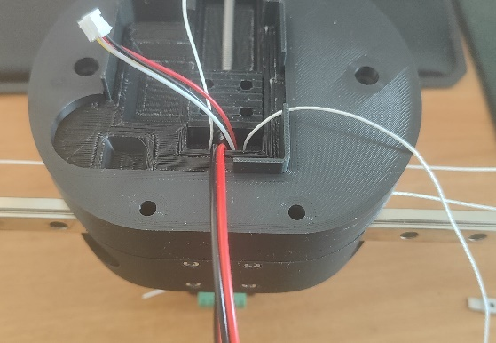

1. Insert 4 ISO 7380 M4x12 screws into the tensioner top part.
2. Tension the rope ends and pull them over the teeth of the tensioner.
3. Place the tensioner top part onto the lower part and screw it tight. You can make it quite tight.

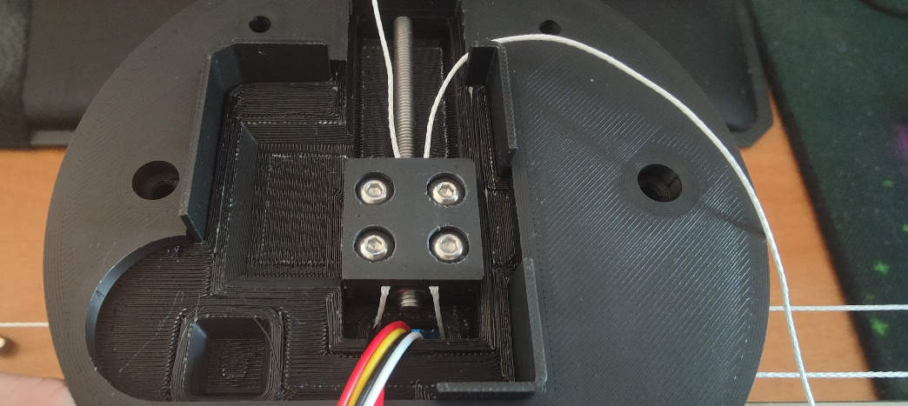

1. Make sure the rope goes over the little blocks on the underside of the Motor Head Front, as pictured below

Ein Bild, das Auto enthält.

1. Mount the Top with 2 M5x45 Hex Cap screws and 2 M5 Nuts on the back
2. Now turn the M5x80 screw to tension the rope. Tension it guitar string tight. Move around the rail a bit and see if anything is wrong. The motion should be very fluent. Make sure the rope wraps are roughly centered on the capstan pulley. If they are not, it may be that it gets hard to push the rail to the end because the rope wraps over itself (thus increasing diameter of the capstan pulley -> longer rope needed). If you have issues with this and can’t get it to work, feel free to write on discord.
3. Hold the rope ends tightly, screw of the tensioner top part, and reset the position of the tensioner back down again. Then screw in the tensioner top part again. This is done so you have some redundancy in retensioning.
4. The rope will stretch a tiny bit over the first few hours of use. Retension accordingly to keep it guitar string tight or even tighter. The tighter the rope is tensioned, the less shifting on the rope on the drum you will have (in extreme conditions). However, too tight of a tension may damage the tape on the capstan pulley over time. Before use, always make sure the rope is properly tensioned.
5. Cut the rope now but leave some redundancy in length.
6. Crimp the cable ends with terminal crimps.
7. Plug the JST cable into the header on the ossm control board and screw in the cable ends into the terminal block
8. Place the ossm control board onto the standoffs with the side with the esp chip facing down.
9. Cut the cables to length and screw the other side into the motors terminal.
10. Finally, screw down the front cover with 4x M5x45 countersunk screws and 4x M5 Nuts on the back.

